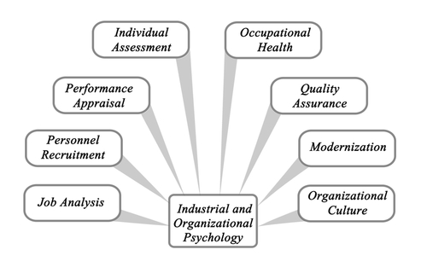

Concentration in I/O Psychology

**DEPARTMENT OF PSYCHOLOGY COURSES**

**PSYC 3520 Introduction to Industrial Organizational**

**Psychology**

3 Hours

COURSE DESCRIPTION

Personnel and organizational psychology; selection and testing procedures, test validation, and theories of organization, leadership and job performance.

Prerequisite(s) PSYC 2317 or equivalent

**PSYC 3100 Social Psychology**

3 Hours

COURSE DESCRIPTION

Survey of psychological research and theory on social behavior with attention to person perception, interpersonal attraction, group processes, attitudes, helping behavior, aggression and applied social psychology.

Prerequisite(s): PSYC 1630 OR PSYC 1650

**PSYC 2580 Health Psychology**

3 Hours

COURSE DESCRIPTION

Examines psychological, physiological, social and behavioral factors as they influence and are influenced by physical health. Health psychology is concerned with the acquisition and maintenance of health through behavior change strategies, the prevention and/or treatment of illnesses, the role of psychosocial and stress factors in the development of physical illness, and the formulation of health care policy.

Prerequisite(s): None.

**PSYC 4030 Multicultural Psychology**

3 Hours

COURSE DESCRIPTION

Study of various theories and concepts of multicultural psychology, the impact of cultural factors on human behaviors, and challenges faced by underrepresented groups in society. Emphasis placed on the development of students’ multicultural knowledge and experience.

Prerequisite(s) Junior or Senior status; PSYC 1630 or PSYC 1650.

**PSYC 4800 Introduction to Perception and Cognition**

3 Hours

COURSE DESCRIPTION

A general survey of current data in perception and cognition. Perception topics covered are psychophysics, sensory psychology, perceptual constancies and the development of perception. Cognition topics include short and long-term memory, problem solving, concept formation and the acquisition of knowledge. The information processing approach is emphasized as a means of interpreting perception and cognition.

Prerequisite(s): PSYC 1630 or PSYC 1650.

**DEPARTMENT OF TECHNICAL COMMUNICATION**

**TECM 2700 Technical Writing**

3 Hours

COURSE DESCRIPTION

Expository writing, especially for science, pre-engineering and business students.

Prerequisite(s) ENGL 1310 or TECM 1700

May be substituted for ENGL 1320 in some programs; students should consult advisors in their majors.

**G. BRINT RYAN COLLEGE OF BUSINESS**

**BUSI 1340 Managing the Business Enterprise**

3 Hours

COURSE DESCRIPTION

Study of managing the business enterprise with an emphasis on leadership with integrity. Overview of managing business organizations and what is needed to succeed in local, domestic, and global markets.

Prerequisite(s): Freshman or sophomore standing. Cannot be used to meet business foundation, business professional field, or business supporting field requirements.

**DEPARTMENT OF MANAGEMENT**

**MGMT 3721 Organizational Behavior**

3 Hours

COURSE DESCRIPTION

Individual behavior in formal organizations. Cases, lectures and experimental exercises in organizational culture, motivation, leadership, dynamics of power, perception and attribution, communication, decision making and performance,, and individual differences.

Prerequisite(s): None

**MGMT 3860 Human Resource Management**

3 Hours

COURSE DESCRIPTION

Introduction to personnel management. Topics include employment, placement and personnel planning, training and development; compensation and benefits; health, safety and security; and employee and labor relations.

Prerequisite(s): None Open to non-business majors.

**MGMT 4300 Recruitment, Selection and Placement**

3 Hours

COURSE DESCRIPTION

Recruitment, selection and placement of employees in an organization. Test validation and other selection techniques relative to EEO, ADA, and AAP laws. Recruiting, selecting and placing a culturally diverse work force.

Prerequisite(s): None

**MGMT 4470 Leadership**

3 Hours

COURSE DESCRIPTION

In-depth course on leadership. Students are provided practical tools and methods of leadership that apply to a variety of organizational structures. Students gain insight about their own personalities, skills ethics, values and beliefs as they relate to leading others, and have the opportunity to discuss and debate a number of leadership topics.

Prerequisite(s): None

**MGMT 4890 Legal Aspects of Employment Practices**

3 Hours

COURSE DESCRIPTION

Current legislation and its impact on human resources policy and practices.

Prerequisite(s): None