Uploading receipts to Concur (How-to)
Step 1: Download the SAP Concur Mobile App (for Android and IOS)
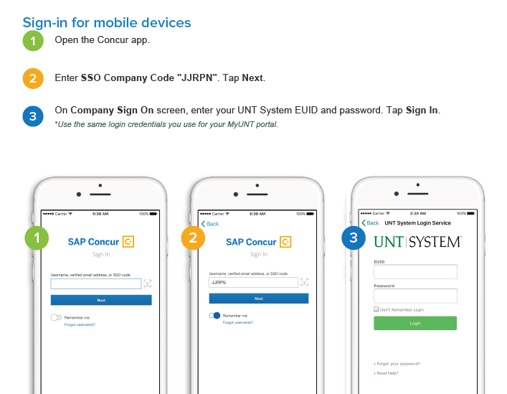
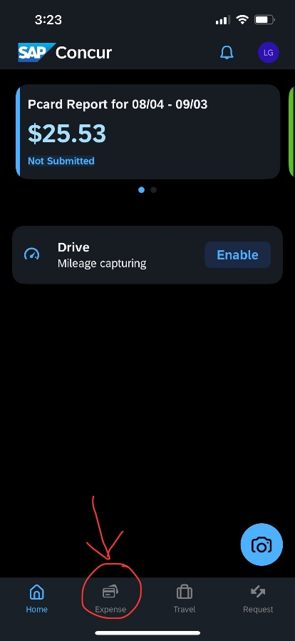
Step 2: Add the receipt
Your Concur homepage should look like this:
Any open reports will show at the top.
Tap the ‘Expenses’ tab at the bottom of the
screen.

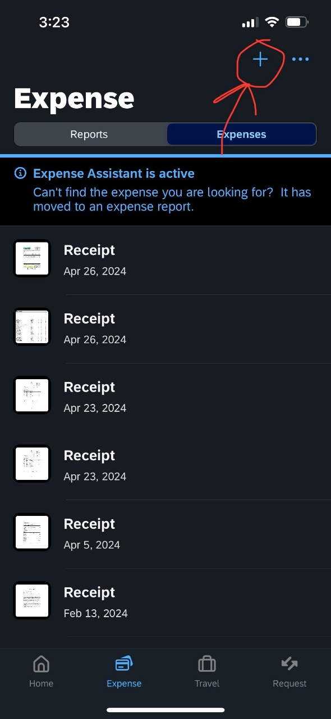
Now, tap the plus (+) sign at the top right.
This will bring a drop-down menu of some
options.
You will want to tap ‘Add Receipt’.
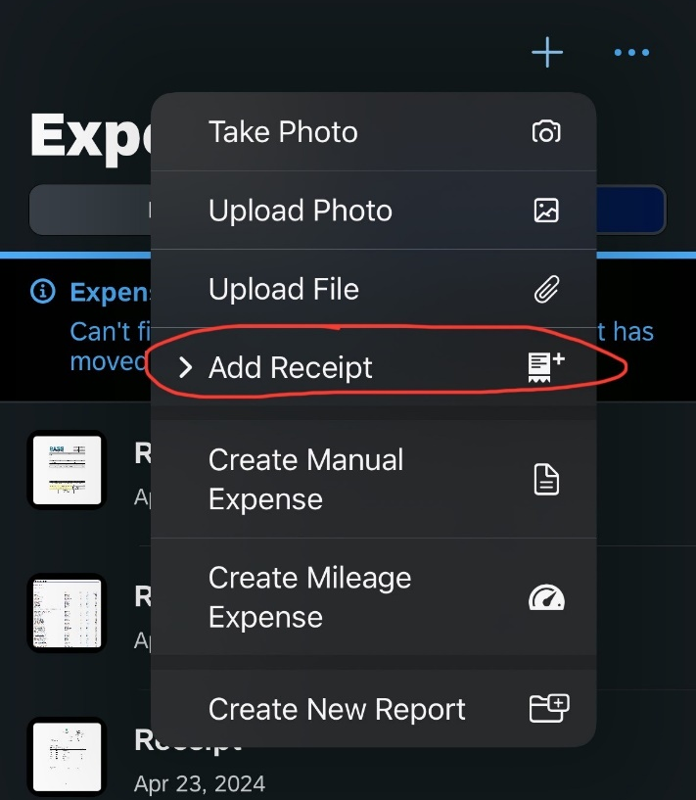

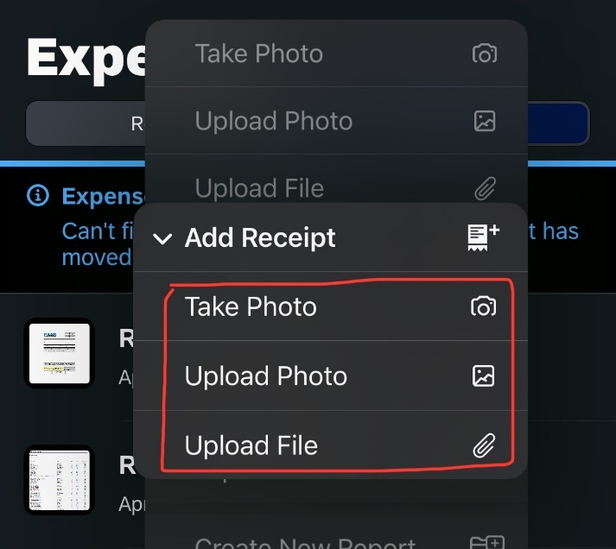
Now, it will show you three ways you can upload a receipt—by taking a photo of it right then and there, uploading a photo you already took from your Photo Library, or uploading a file document. Choose the one that fits your needs.

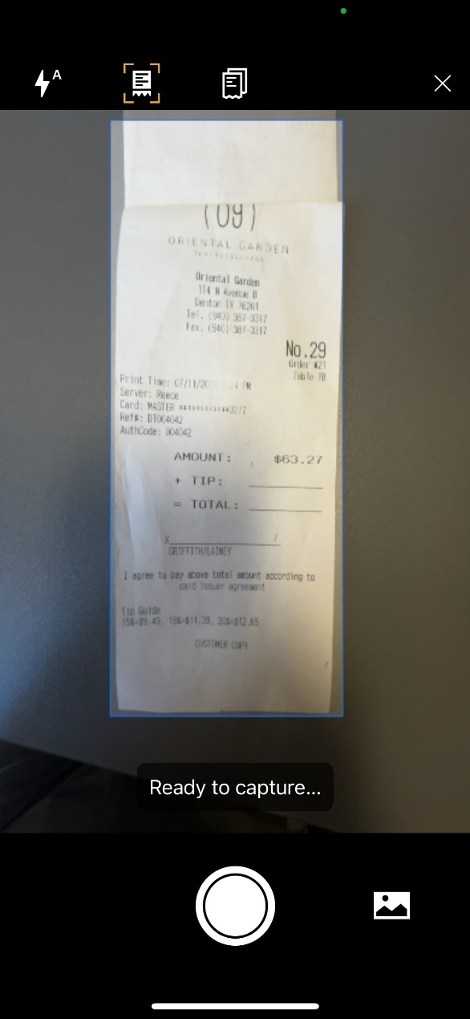
If taking a photo, here is what this will look like.
Notice how it automatically fits the screen to
capture the receipt.

Now, it will pop up in your list of expenses shown
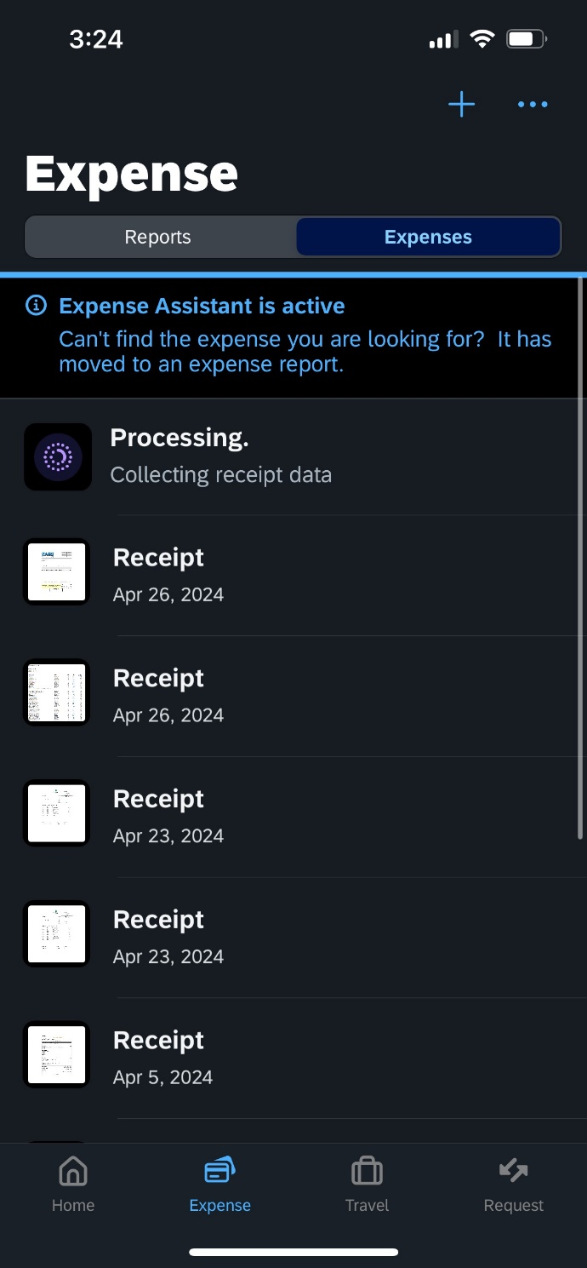
here. And… you’re done!

